SQL Basics
- Create a New Database and Table for Employees
Task: Create a new database named company_db and create a table named employees with the following columns:

Column Name | Data Type | Constraint
employee_id | INT | PRIMARY KEY
first_name | VARCHAR(50)
last_name | VARCHAR(50)
department | VARCHAR(50)
salary | INT
hire_date | DATE

- Create database company_db;
- Use company_db;
- create table employees
(employee_id int Primary key,
first_name Varchar(50),
last_name Varchar(50),
department Varchar(50),
salary int,
hire_date DATE);

- select * from employees;

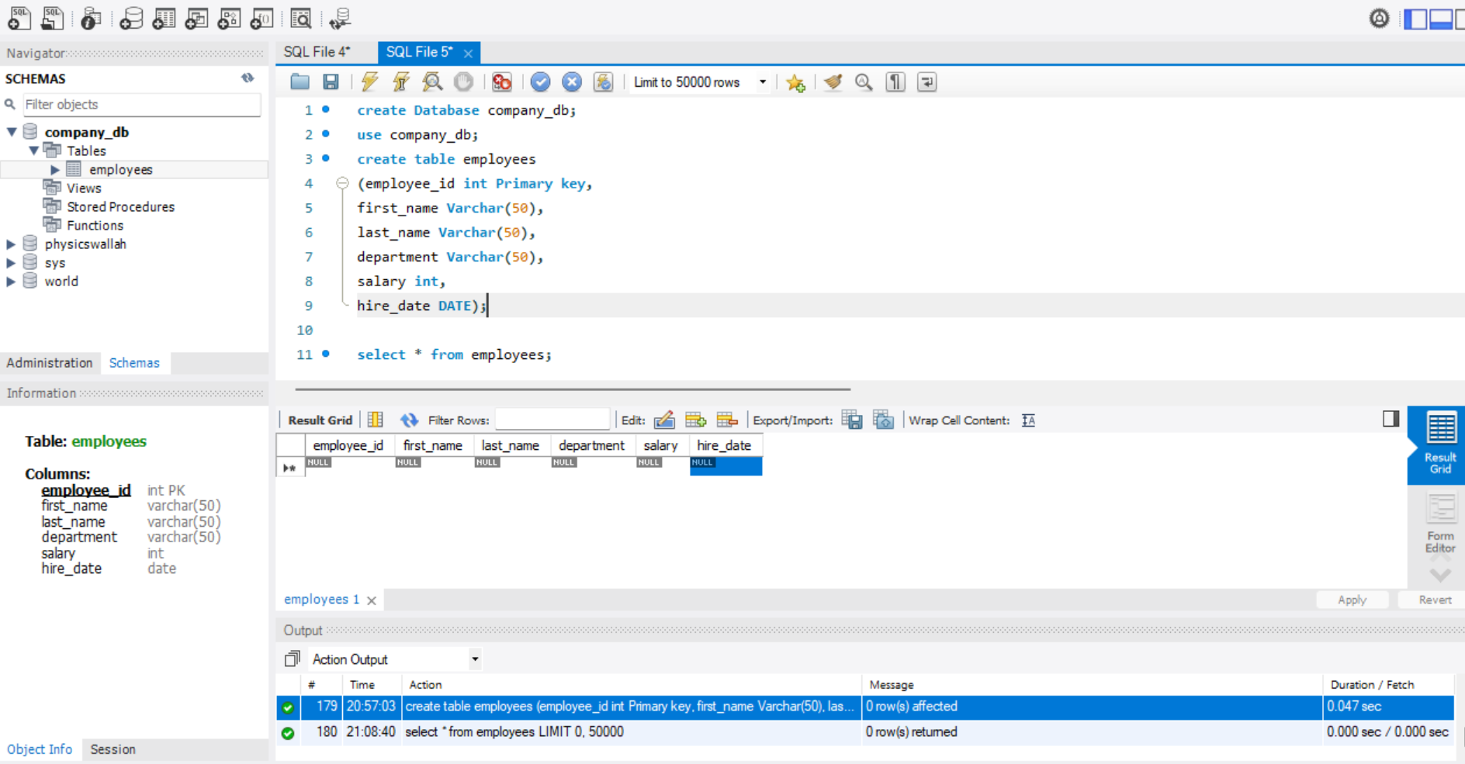

- Insert Data into Employees Table Task: Insert the following sample records into the employees’ table.
employee_id | first_name | last_name | department | salary | hire_date
101 | Amit | Sharma | HR | 50000 | 2020-01-15
102 | Riya | Kapoor | Sales | 75000 | 2019-03-22
103 | Raj | Mehta | IT | 90000 | 2018-07-11
104 | Neha | Verma | IT | 85000 | 2021-09-01
105 | Arjun | Singh | Finance | 60000 | 2022-02-10

- INSERT INTO employees
(employee_id, first_name, last_name, department, salary, hire_date)
VALUES
(101, 'Amit', 'Sharma', 'HR', 50000, '2020-01-15'),
(102, 'Riya', 'Kapoor', 'Sales', 75000, '2019-03-22'),
(103, 'Raj', 'Mehta', 'IT', 90000, '2018-07-11'),
(104, 'Neha', 'Verma', 'IT', 85000, '2021-09-01'),
(105, 'Arjun', 'Singh', 'Finance', 60000, '2022-02-10');
- select * from employees;

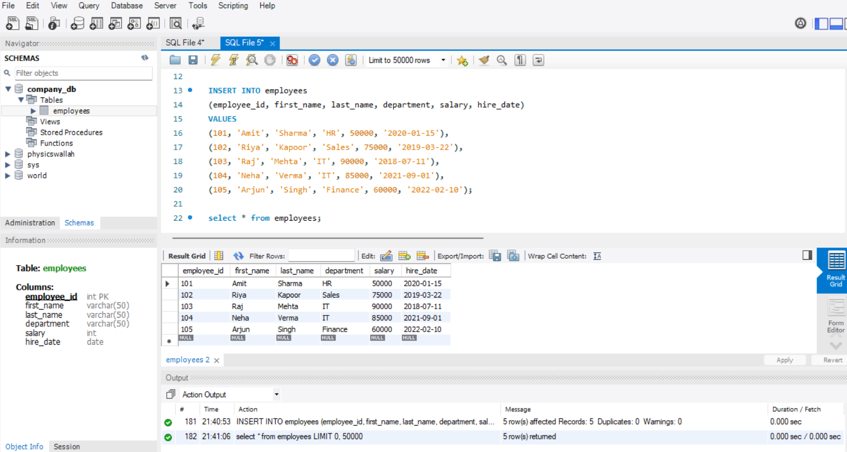

- Display All Employee Records Sorted by Salary (Lowest to Highest)
Hint: Use the ORDER BY clause on the salary column.
- SELECT *
FROM employees
ORDER BY salary ASC;
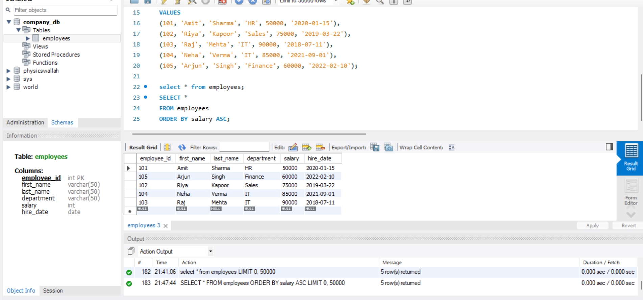

- Show Employees Sorted by Department (A–Z) and Salary (High → Low)
- SELECT *
FROM employees
ORDER BY department ASC, salary DESC;

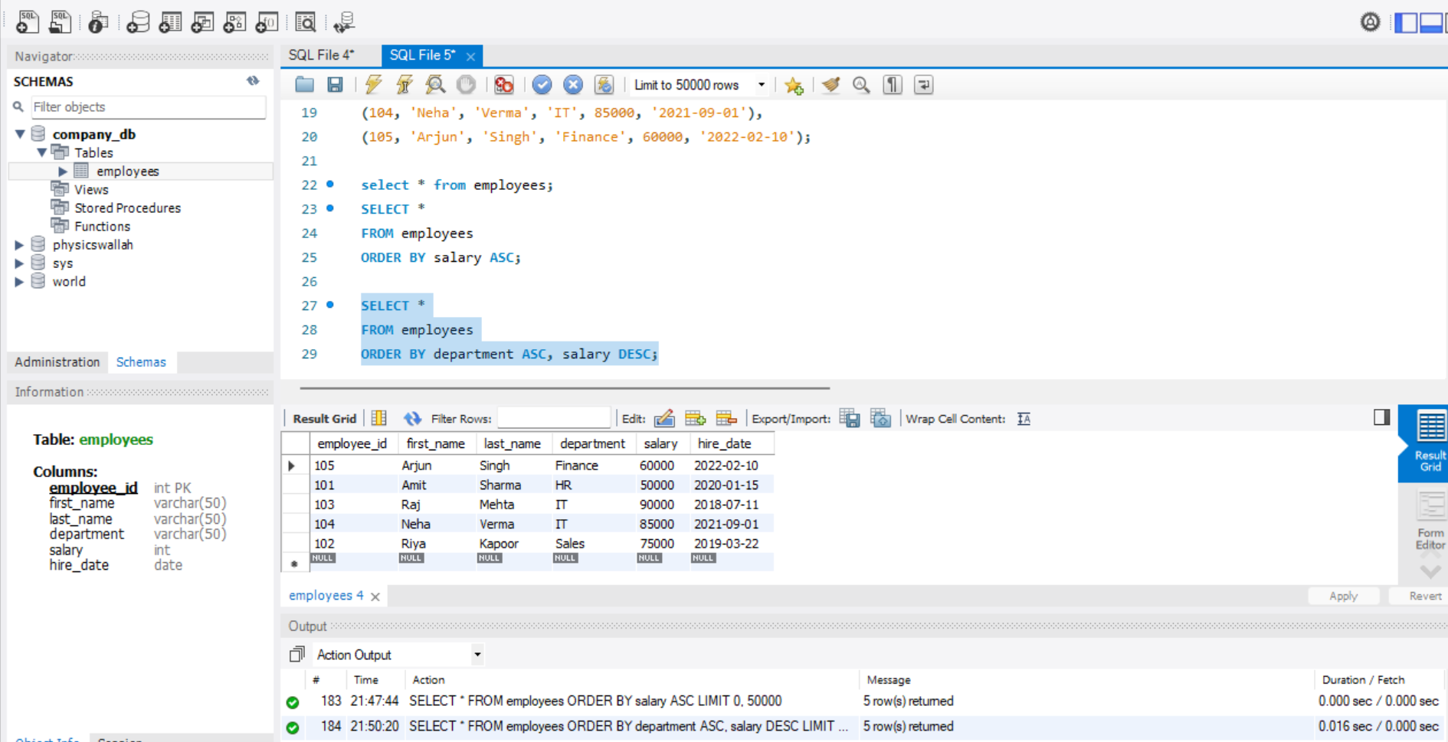

- List All Employees in the IT Department, Ordered by Hire Date (Newest First)
- SELECT *
FROM employees
WHERE department = 'IT'
ORDER BY hire_date DESC;

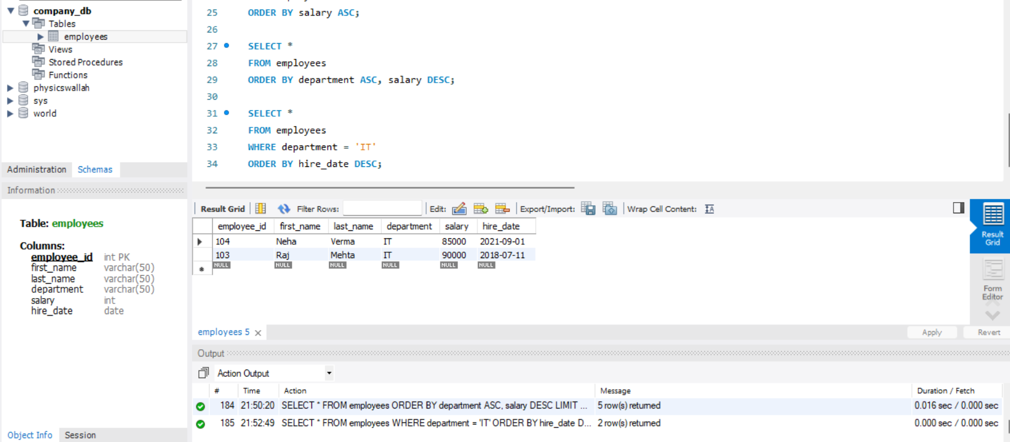

- Create and Populate a Sales Table Task: Create a table sales to track sales data:
sale_id | customer_name | amount | sale_date
1 | Aditi | 1500 | 2024-08-01
2 | Rohan | 2200 | 2024-08-03
3 | Aditi | 3500 | 2024-09-05
4 | Meena | 2700 | 2024-09-15
5 | Rohan | 4500 | 2024-09-25

- CREATE TABLE sales (
sale_id INT PRIMARY KEY,
customer_name VARCHAR(50),
amount INT,
sale_date DATE
);
- select * from sales;

- INSERT INTO sales
(sale_id, customer_name, amount, sale_date)
VALUES
(1, 'Aditi', 1500, '2024-08-01'),
(2, 'Rohan', 2200, '2024-08-03'),
(3, 'Aditi', 3500, '2024-09-05'),
(4, 'Meena', 2700, '2024-09-15'),
(5, 'Rohan', 4500, '2024-09-25');

- select * from sales;

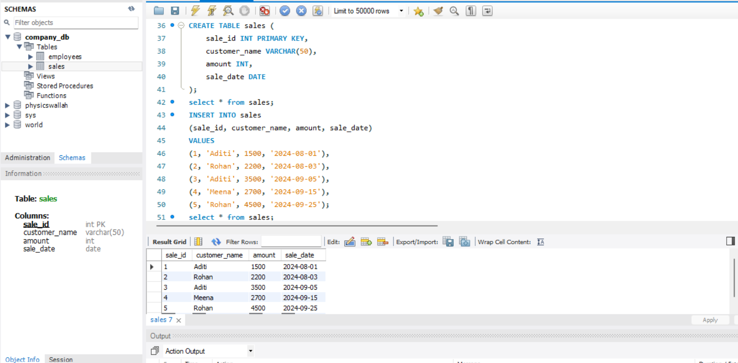

- Display All Sales Records Sorted by Amount (Highest → Lowest)
Hint: Use ORDER BY amount DESC
- SELECT *
FROM sales
ORDER BY amount DESC;

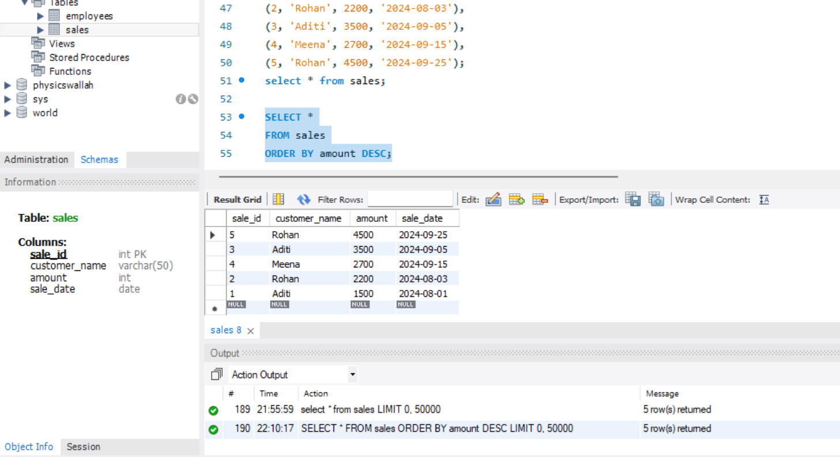

- Show All Sales Made by Customer “Aditi”
Hint: Use WHERE customer_name = 'Aditi'
- SELECT *
FROM sales
WHERE customer_name = 'Aditi';

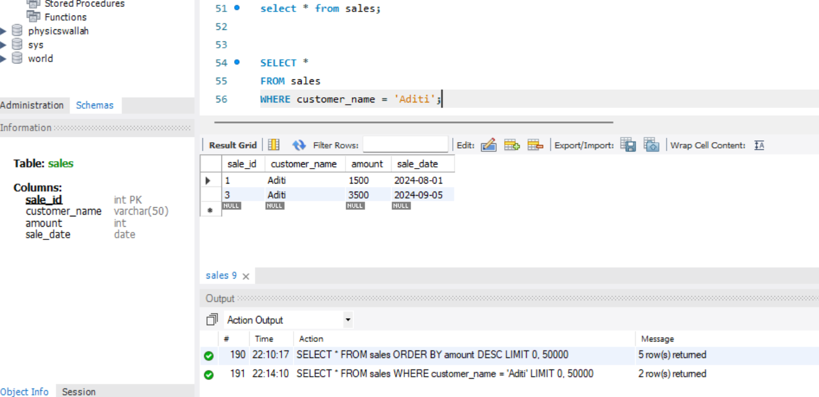

- What is the Difference Between a Primary Key and a Foreign Key?
- A primary key uniquely identifies each record within a single table, ensuring entity integrity, while a foreign key establishes a relationship between two tables by referencing the primary key of another table. Only one primary key is allowed per table (no NULL values), whereas multiple foreign keys can exist, often allowing NULL values.

- What Are Constraints in SQL and Why Are They Used?
- Constraints are rules applied to table columns to control the type, range, and validity of data that can be stored in a database.
- Constraints are used to:
- Ensure data accuracy
- Maintain data integrity
- Prevent invalid data entry
- Enforce business rules
- Maintain relationships between tables

